Where’s the fish?

One of the most common questions in fisheries is “where are the fish?” Doesn’t matter if you’re a fisher, a manager, or a researcher; everyone wants to know where the fish are. I’m Kat, a second-year PhD student in the School of Aquatic and Fisheries Sciences at the University of Washington, Seattle who is trying to answer this question. I was funded by the Marine Stewardship Council to assist the Environmental Defense Fund (EDF) in developing a formalized way to predict where the fish hang out. So, what have I done? Well, I started by figuring out what fish like, and then looked for locations that had these characteristics. Fishermen do this all the time, it’s one of the reasons the Gulf of Maine (for example) has historically been such a hotbed of fishing activity; all the small bumps on the seafloor there create ideal conditions for many fish species. There’s a catch though. Fish have life cycles that consist of several stages. Often the environmental conditions suitable to one life stage are not ideal for another stage. Surprisingly, this reality is rarely incorporated into the models used to predict fish spatial distributions. Furthermore, our oceans’ environmental conditions are shifting as a result of climate change. These shifts are transforming fish distributions and abundances, challenging long-standing assumptions about prime fishing locations and seasons, and thus complicating regional fisheries management agreements.

Knowing this, the EDF and I set out to create a model that could find the fish! We selected a species of interest (Indonesian Blue Swimming Crab, IBSC), and a region of the globe (Southeast Asia), and began designing a model that could:

1. include multiple environmental parameters,
2. account for multiple life stages, and
3. be easily applied to different species, environmental conditions, and global regions.

Here’s how it went.

First, I read through the literature on IBSC. Indonesia produces roughly 31% of the world’s blue swimming crab. It is the leading exporter with nearly 40,000 tons of crab contributing approximately US$179 million annually towards Indonesia’s GDP. Fisheries in the IBSC Fisheries Improvement Project (FIP) span nearly the entire country, and employ around 275,000 diverse fishers and pickers. These crabs go through five life stages (egg, zoea, megalopae, juvenile, and adult), each of which depend on distinct habitat types. Crabs can survive only within a range of temperatures, salinities, oxygen levels, and acidities; and ideal conditions differ depending on life stage. We don’t have exact ideal conditions for each life stage of this crab, but I complied what I could find to estimate IBSC preferences across these parameters, specific to each of its five life stages.

Next, I gathered geospatial ocean data from several sources. I needed data on the pH, temperature, dissolved oxygen, and salinity of Southeast Asian waters, with observations taken at multiple depths since conditions at one depth differ dramatically from conditions at another depth. Plus, IBSC are known to inhabit only certain depths, and migrate during their life cycle. These observations also needed to cover a long time span since aquatic environments constantly fluctuate, and be at a high enough spatial resolution to be informative to fisheries managers. Also, since climate change is altering oceanic conditions, I gathered future predicted conditions, too. My resultant dataset covered four depth categories (surface, 30m, 100m, and a generic ‘bottom’ category), and years 1956-2010, with predictions out to year 2100.

Having gathered my data, I created a model to define areas more or less suitable to IBSC. Suitable areas have conditions that match IBSC’s preferences (specific to each life stage); the greater the difference between the preferred conditions and those observed/predicted, the less suitable that area. Great. That seemed straightforward enough. But then, what about averages versus extremes? My IBSC data contained ranges of preferred environmental parameters. And my ocean observations/predictions dataset also had multiple values for each location. Should I consider maximums and minimums or averages? I decided to create two versions of the model: the Average Version calculates the difference between the average of the observation/prediction data and the average of the preference data, the Extremes Version calculates the difference between the maximum or minimum values of the observation/ prediction data and preference data. Finally, how to handle comparisons? Suppose we want to know if one region’s pH differences are more severe than its temperature differences? How can we do that when each environmental parameter has its own scale (a one-unit change in pH is much larger than a one-unit change in temperature). Or, what if I don’t care about the specific parameters so much as which region is overall more suitable. This requires a composite metric that combines parameters and life stages. I followed the process below to address these concerns; normalizing so that a one-unit difference was uniform across all parameters, scaling to make things more intuitive, taking absolute values and summations to create ranks, and applying weights since it is possible that IBSC might be more sensitive to a change in one particular parameter versus another, or that one of its life stages is relatively more important than another for its survival.

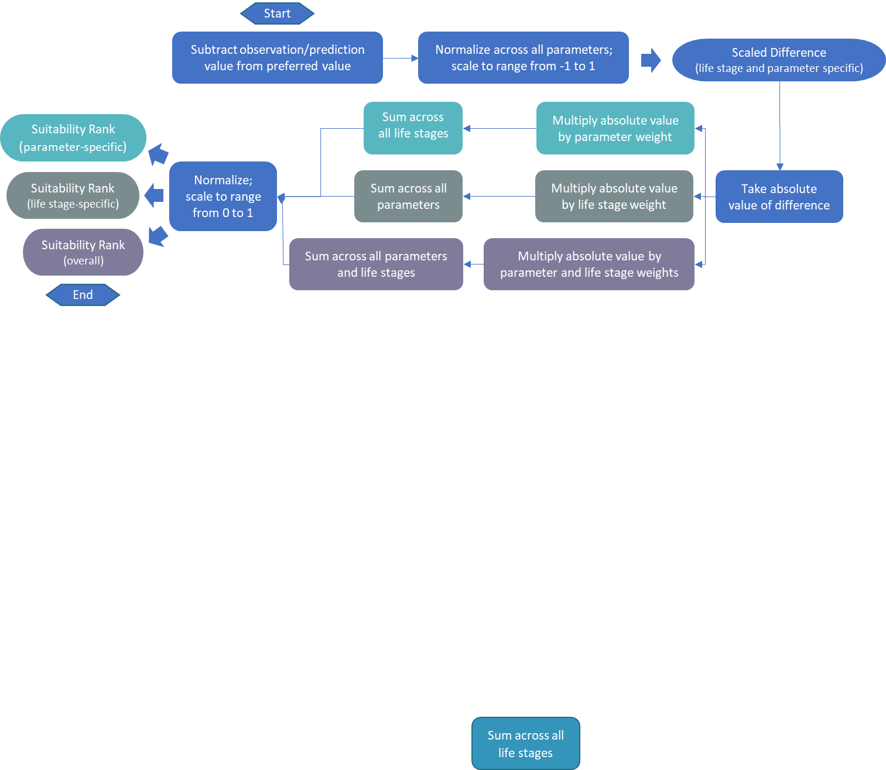

To check the validity of my model, I compared my results against two sources of information: IBSC fishery catch data, and maps from Aquamaps (a website that uses its own approach to estimate spatial distributions of species). Encouragingly, my results were similar to that of Aquamaps, and were supported by the IBSC catch data. Locations I predicted to be suitable were locations where lots of crabs were caught!

Having processed my data, I depicted the results via color coded maps. I chose the continuous coloring scales viridis and magma because these palettes have large perceptual ranges, making as much use of the available color space as possible while maintaining uniformity, and are also more color-blind friendly. In order to produce maps where the colors blended smoothly from one data point to the next, I used spatial interpolation, a process that basically fills in the gaps between data points with the average value of the nearest data points.

Finally, I made this model adaptable and user-friendly. All the data was processed in R files available online. I created an R shiny application that allows anyone to produce the IBSC maps. The app also allows users to download the IBSC data files, as well as upload their own data files for visualization. Users can alter the life stages, parameters, and corresponding weights to suit their own analyses. In this way, my model can be applied to any aquatic organism in any region of the globe! An instruction guide and technical report are included, too.

This project was quite an undertaking as it involved a lot of skills that I hadn’t necessarily developed yet. But because of this, I learned a ton. Plus, I’m pretty happy with the final result. I hope that others will make use of the tool I’ve created to help with their own research, management decisions, or even just selecting where to go fish.